PRIVATE DINNERS IN THE LIBRARY AND BALLROOM.

21 @ the Frederick’s private rooms are the ideal setting for hosting pharmaceutical and medical device meetings. Located in
the historic Frederick Building in Huntington, West Virginia. We gladly accommodate large groups from 10 to 50 for
pharmaceutical and medical device presentations. Our
professional team will ensure that hosting an event at 21 @ the
Frederick is a pleasure for both the host and their guests. Private menus, created by Chef James Hillen, are customized to fit your needs and budget. The library room has a $1,000 food and
beverage minimum whereas the Ballroom has a $1500 food and beverage minimum. Our Library Room holds up to 11 people, the and the Ballroom holds up to 150 people or more. Please inquire below or contact us for availability and details at
21clubfrederickevents@gmail.com or call 304-529-0222 and ask for Brian Johnson (Manager) or Mark Cross (Owner).

PHARMACEUTICAL AND MEDICAL DEVICE PACKAGE
(includes three or four course dinner, soft beverages, 7%tax & 19% gratuity)
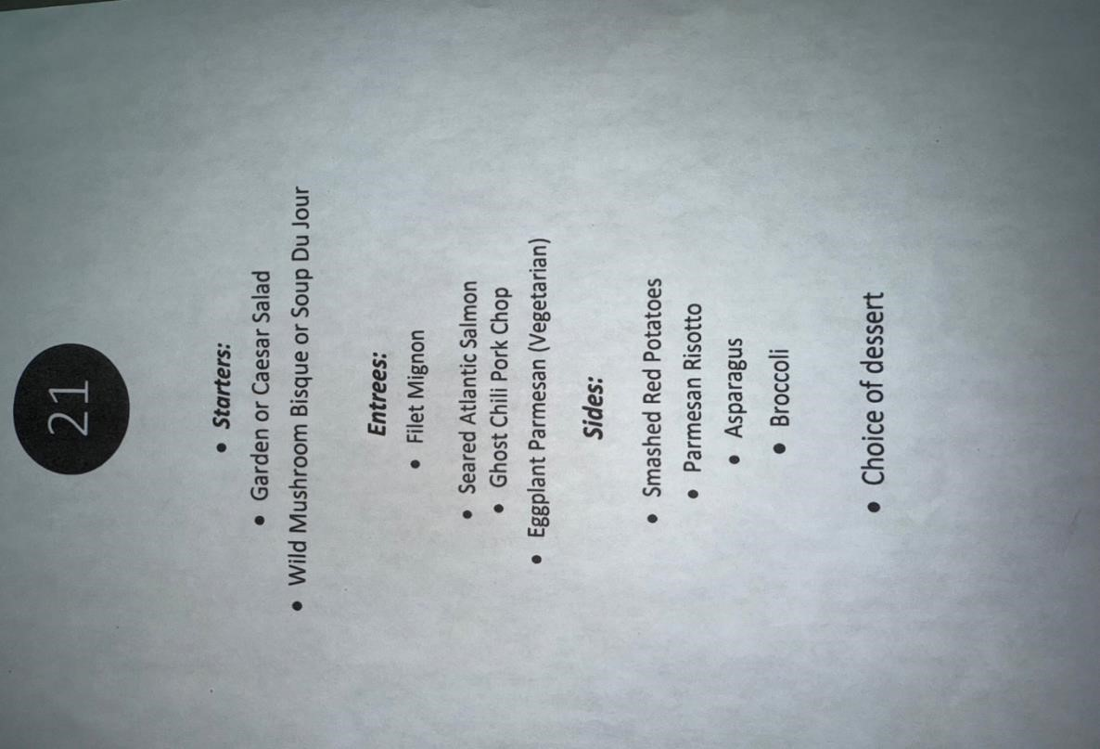
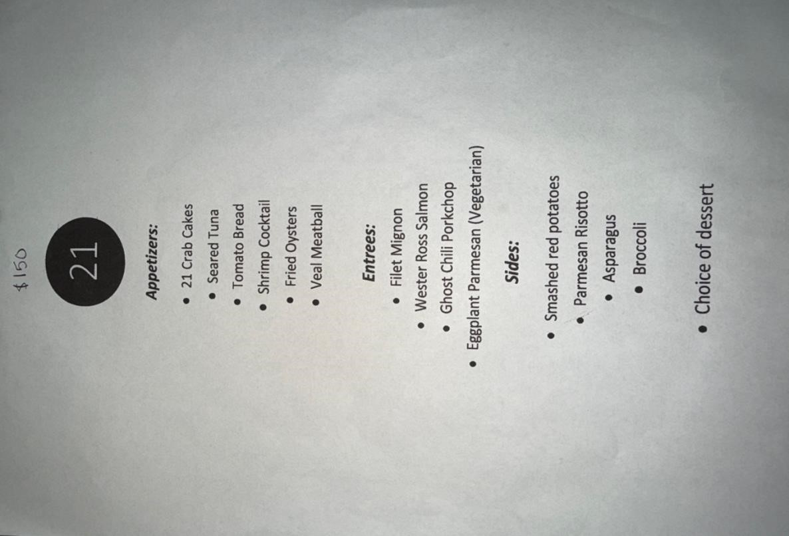

$125 Menu $150 Menu

FAQ:

- Please choose between Library or Ballroom:
- Both rooms are completely private with four walls, closed door, with no windows, no recording devices, no backs to the screen, no columns blocking presentation, and no live music will disturb meeting.
- The Room fee for the Ballroom and Library is $500. The reservation will not be confirmed until room fee is paid.
- A $50 Administration fee will be charged with the room fee. With the $500 room fee, $50 admin fee, and 3% credit card surcharge fee, the bill will total $567.50.
- The room fee transaction AND final bill will include a 3% credit card surcharge fee that cannot be taken off.
- The room fee acts as a cancelation fee and is nonrefundable. No cancelation fee.
- Food and Beverage minimum is $1,000 for the library and for $1,500 Ballroom.
- Receipts will reflect how many guests attended at $125 or $150 including tax and gratuity and an unmet minimum if necessary. We charge $98.17 or $117.81 so after tax and gratuity the total is $125.00 or $150.00 per person based on menu choice.
- No Alcohol, mocktails, or gift cards will be charged to final bill. Guests can start own separate tab with server.
- Audio and visual are included in all rooms at no cost. Large flatscreen TVs with sound. HDMI compatible laptops are preferred but we do have Apple adapters available. Third party audio and visual companies are allowed but are not necessary.
- Final headcount due 48 hours prior to event.
- Unmet minimum will be charged if headcount is under final headcount and will be charged as $125 per person including tax and gratuity on receipt.
- Vegetarian, Vegan, and Gluten intolerant options are available.
- Venue is not located in a resort, spa, winery or casino.
- Street parking is available on 4th avenue, 9th street, 10th street, and parking garage located on the corner of 4th Ave and 10th Street.
● Free on-site WIFI.
- There will not be another pharm party booked in the same room.
- To-go orders are restricted and will not be on final receipt.
- The host may arrive any time before the reservation to set up and get ready.
● All rooms are wheelchair accessible.
- Room fee and final bill receipt can be emailed by request.
- We will sign a third-party contract, but most information is provided in this document.

Please select which room would best fit your party’s needs, the Ballroom or Library.

Please select $125 or $150 menu:

Event Name:

Event Date:

Expected Attendees:

Event Start Time:

Onsite Host:

Onsite Host Phone Number:

Third Party Contact Name:

Third Party Phone Number:

Third Party Email:

Credit Card Authorization Form

Cardholder Name (as shown on card):

Card Number:
Expiration Date (mm/yy):

CVV Number:

Cardholder ZIP Code (from credit card billing address):

I, allow 21 @ the Frederick to charge my credit card listed above for agreed upon purchases at 21 Club @ the Frederick.
Date:

Customer Signature:

Date:

21 @ the Frederick Signature:

